Complete all questions on this sheet for credit. Show work in order to receive credit.
- Find the domain: $f\left(x\right)=\sqrt{2x-5}$

Domain: __________________
- Write an equation for the graph pictured below:
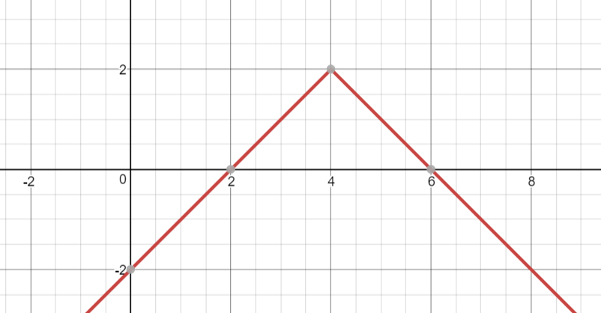

Equation: _________________

- Given the functions: $g\left(x\right)=2x+3$ and $h\left(x\right)=x^{2}+5x-4$, find and completely simplify $(h∘g)(x)$.

Composition: ______________
- For the function f given by $f\left(x\right)= \frac{3}{5}x-8$, find $f^{-1}(x)$.

$f^{-1}(x)$: ___________________

